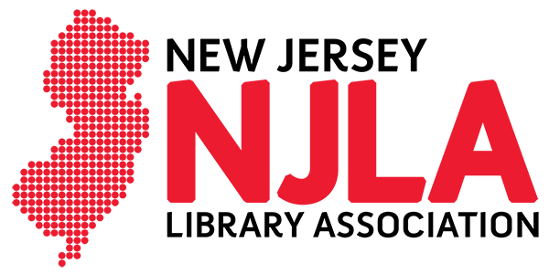
163 US Hwy 130 N, Bldg. 1, Suite 1C, Bordentown, NJ 08505 609-482-1282 http://www.njla.org

March 22, 2021

Links to Some Resources on AAPI Anti-Racism

Asian/Pacific American Librarian Association (APALA)
APALA Statement Against Anti-Asian Violence
2021 COVID-19 anti-xenophobia and anti-racist information resources
COVID-19 Anti-Asian Racism Resources for K-12

Anti-Asian Violence Resources

Cherry Hill Public Library
https://chplnj.org/anti-racism

Hollaback!
Free virtual bystander intervention training on anti-Asian/American and xenophobic harassment

